Join , Natural join, cross join, inner join, outer join, left outer , right outer , left inner , right inner, having clause,

1. mysql> select emp.ename,dept.dname from emp,dept where emp.deptno=dept.deptno order by dname;

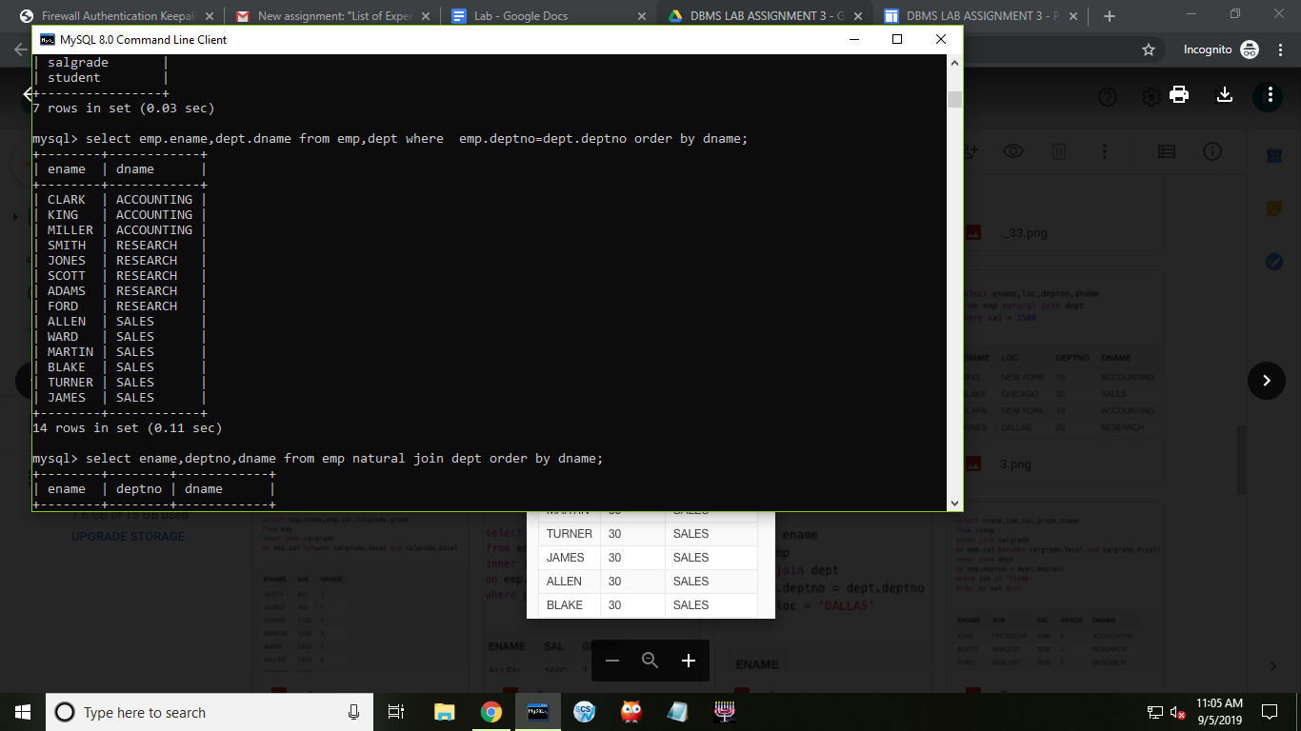

//Alternative

mysql> select ename, dname from dept right join emp on dept.deptno=emp.deptno order by dname;

1. mysql> select ename,deptno,dname from emp natural join dept order by dname;

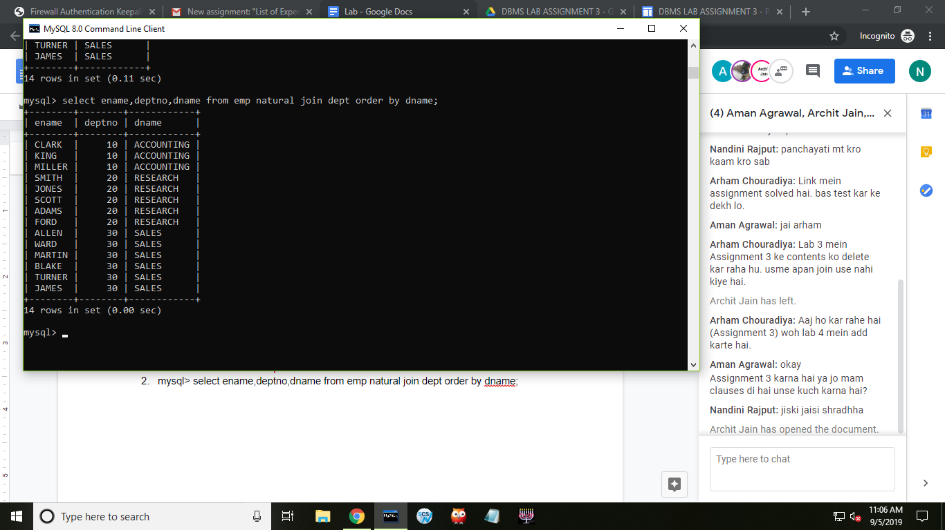

1. mysql> select ename,loc,deptno,dname from emp natural join dept where sal>1500;

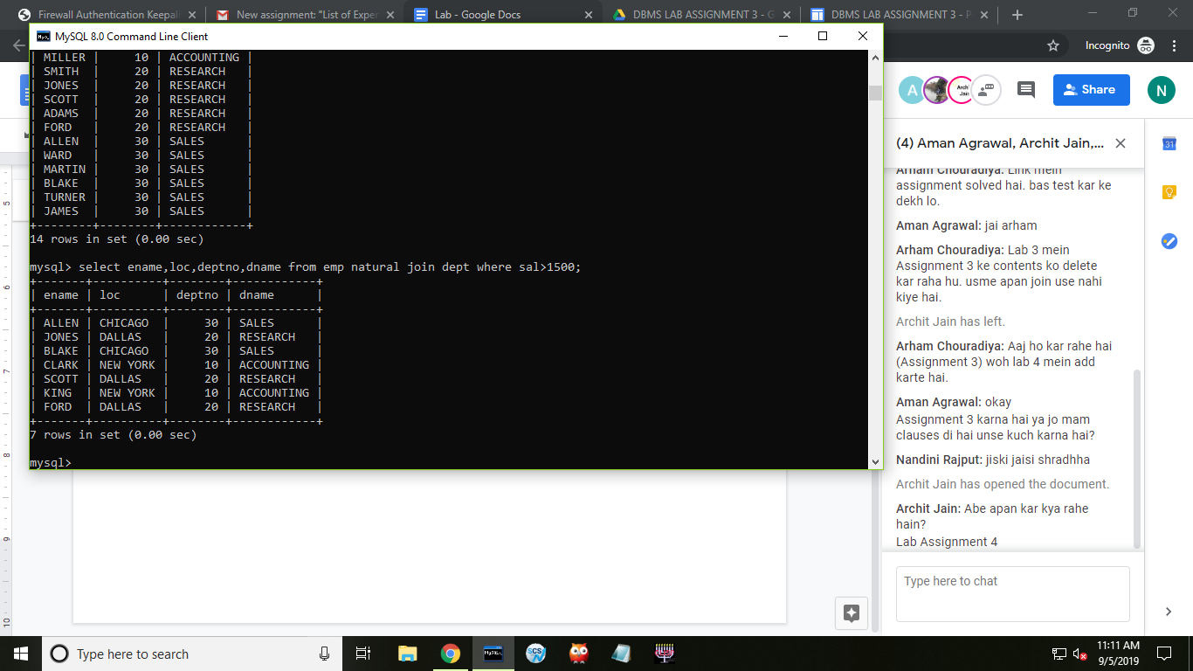

1. mysql> select emp.ename,emp.sal, salgrade.grade from emp inner join salgrade on emp.sal between salgrade.losal and salgrade.hisal;

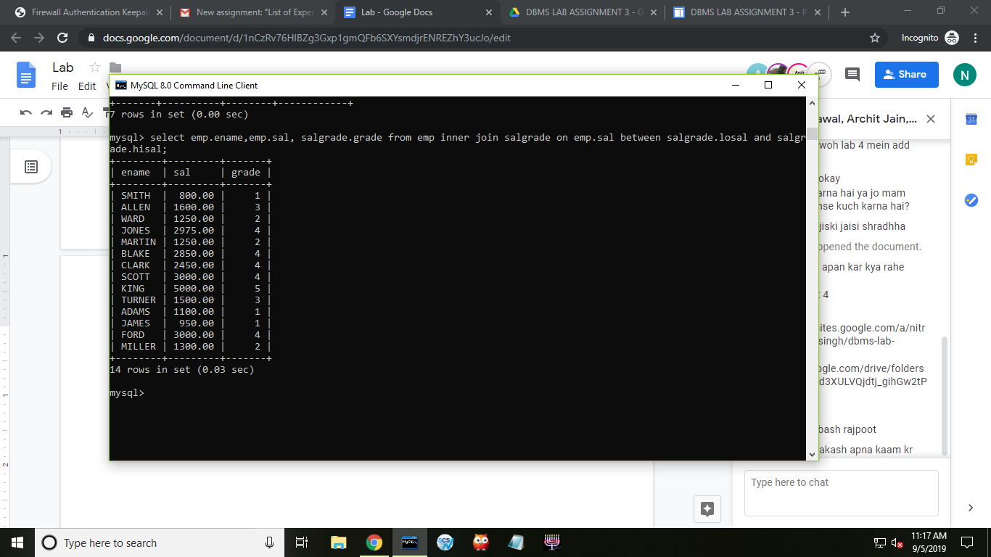

1. mysql> select emp.ename,emp.sal, salgrade.grade from emp inner join salgrade on emp.sal between salgrade.losal and salgrade.hisal where grade=3;

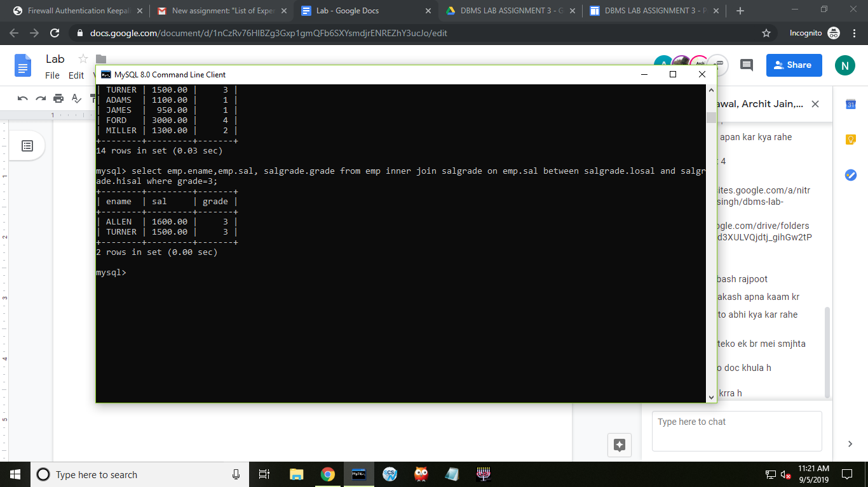

1. mysql> select ename from emp inner join dept on emp.deptno=dept.deptno where loc='DALLAS';

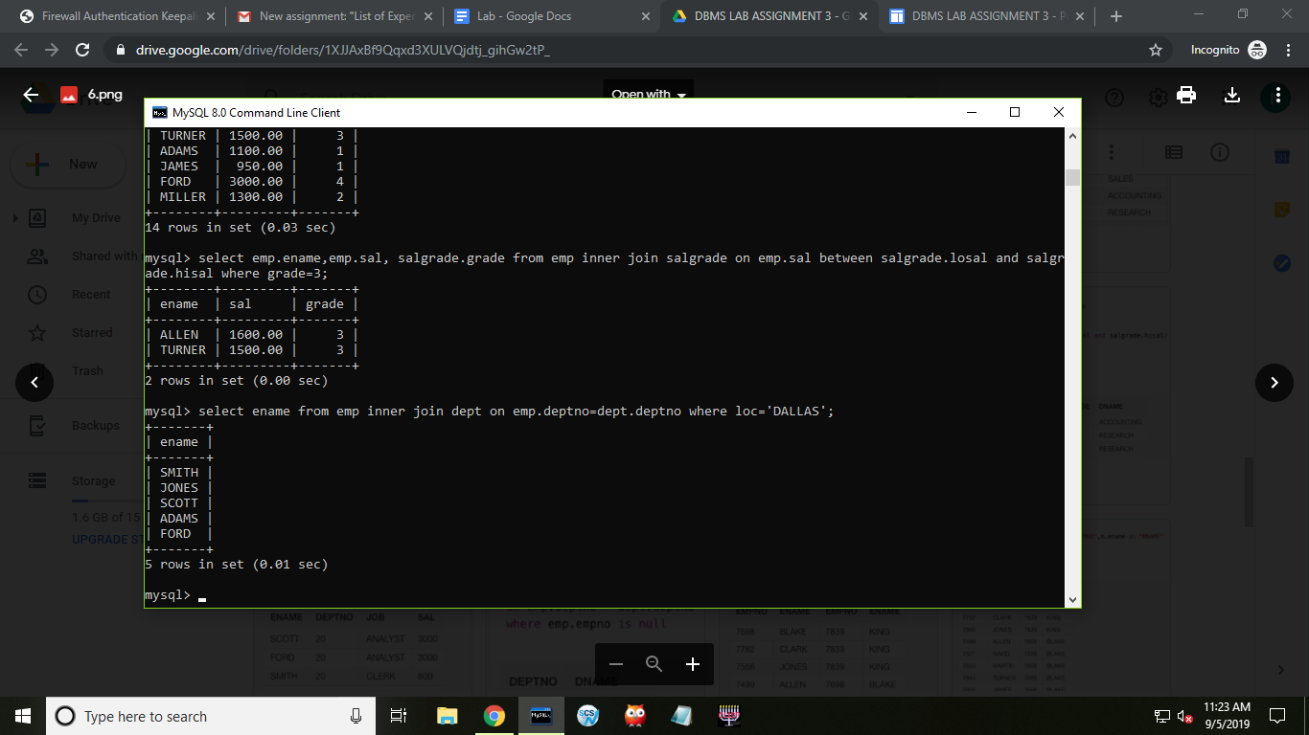

1. mysql> select ename,job,sal,grade,dname from ((emp inner join salgrade on emp.sal between salgrade.losal and salgrade.hisal) inner join dept on emp.deptno=dept.deptno) where job!='CLERK' order by sal desc;

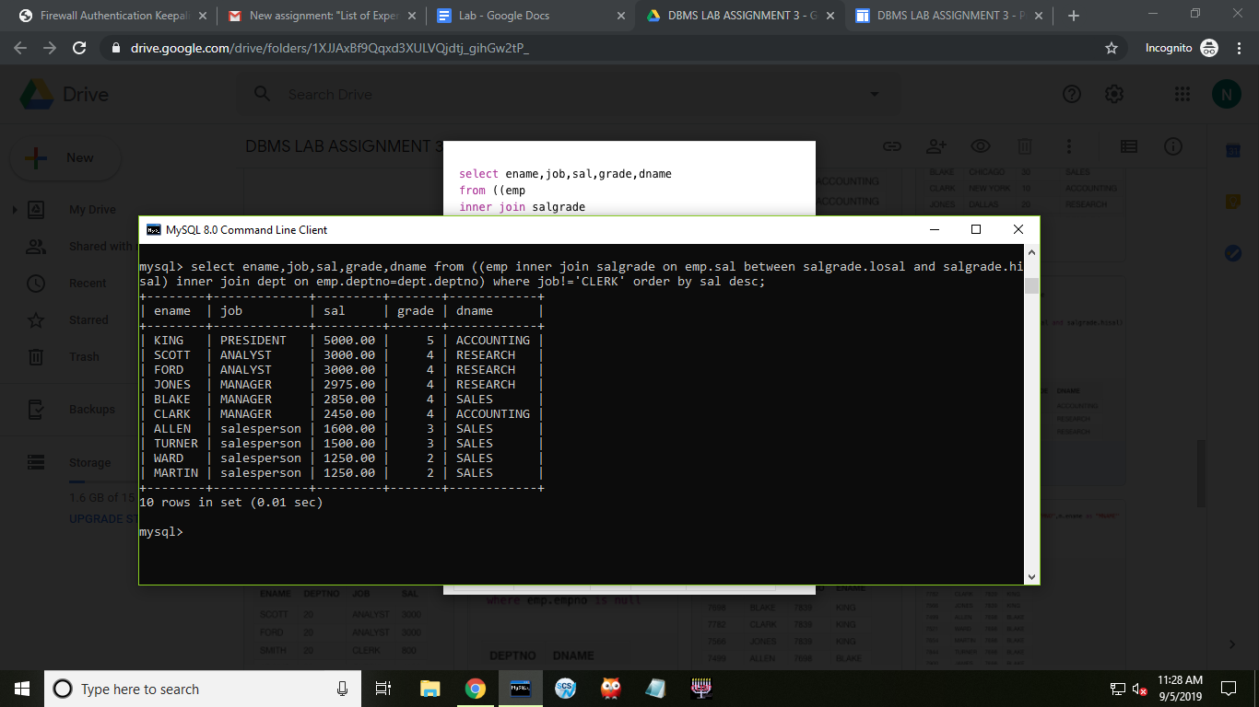

1. mysql> select ename,deptno,job,sal from emp where (sal*12)=36000 or job='CLERK';

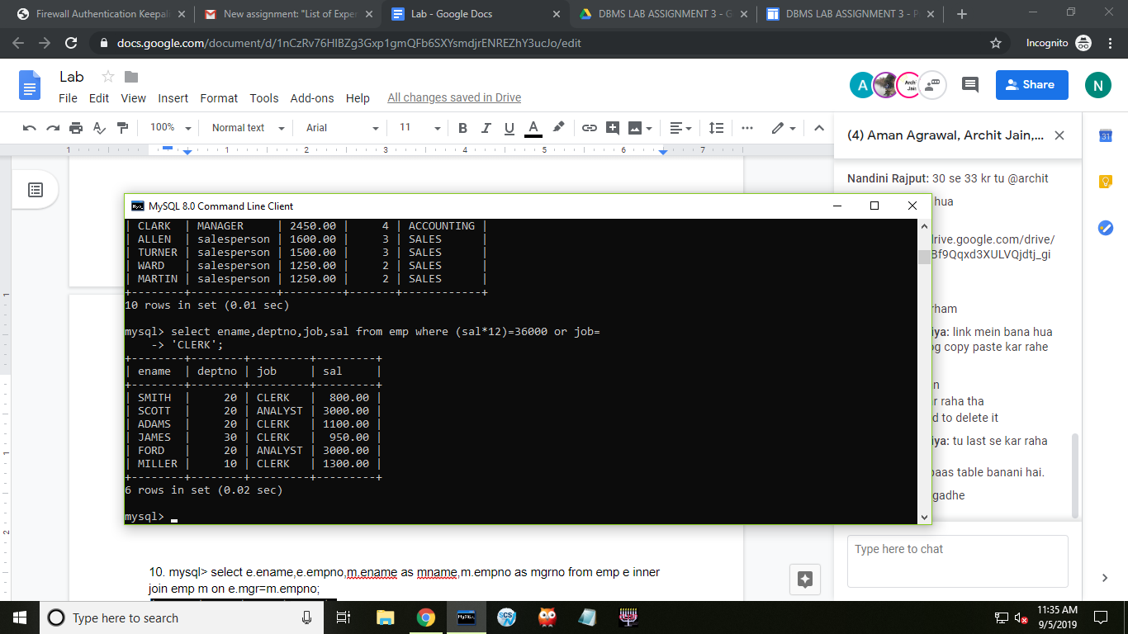

1. mysql> select dept.deptno,dname,loc from emp right join dept on emp.deptno=dept.deptno where empno is null;

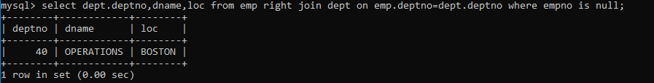

10. mysql> select e.empno,e.ename,m.empno,m.ename from emp e, emp m where e.mgr=m.empno;

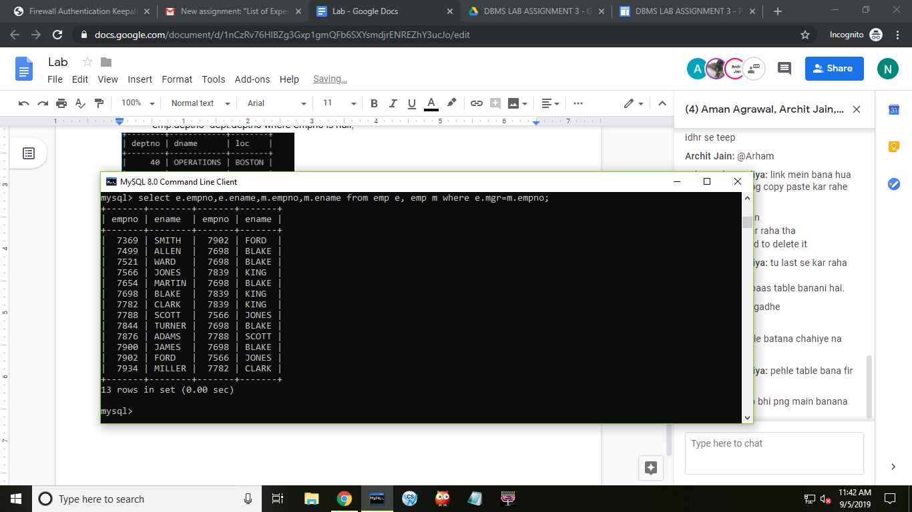

11. mysql> select e.ename,e.empno,m.ename as mname,m.empno as mgrno from emp e left join emp m on e.mgr=m.empno where m.empno is null;

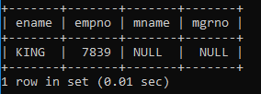

12. mysql> select * from emp where month(hiredate)<=06 and year(hiredate)=1993 and job in (select job from emp where month(hiredate)<=06 and year(hiredate)<=1994);



13. mysql> select e.ename,e.hiredate,m.ename as mname,m.hiredate from emp e inner join emp m on e.mgr=m.empno and e.hiredate<m.hiredate;

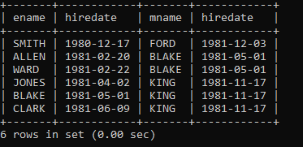

14. mysql> select d.dname from dept d where (select count(*) from emp e where e.deptno=d.deptno)=0;

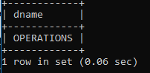

15. mysql> select * from emp where sal in (select max(sal) from emp group by job) order by sal desc;

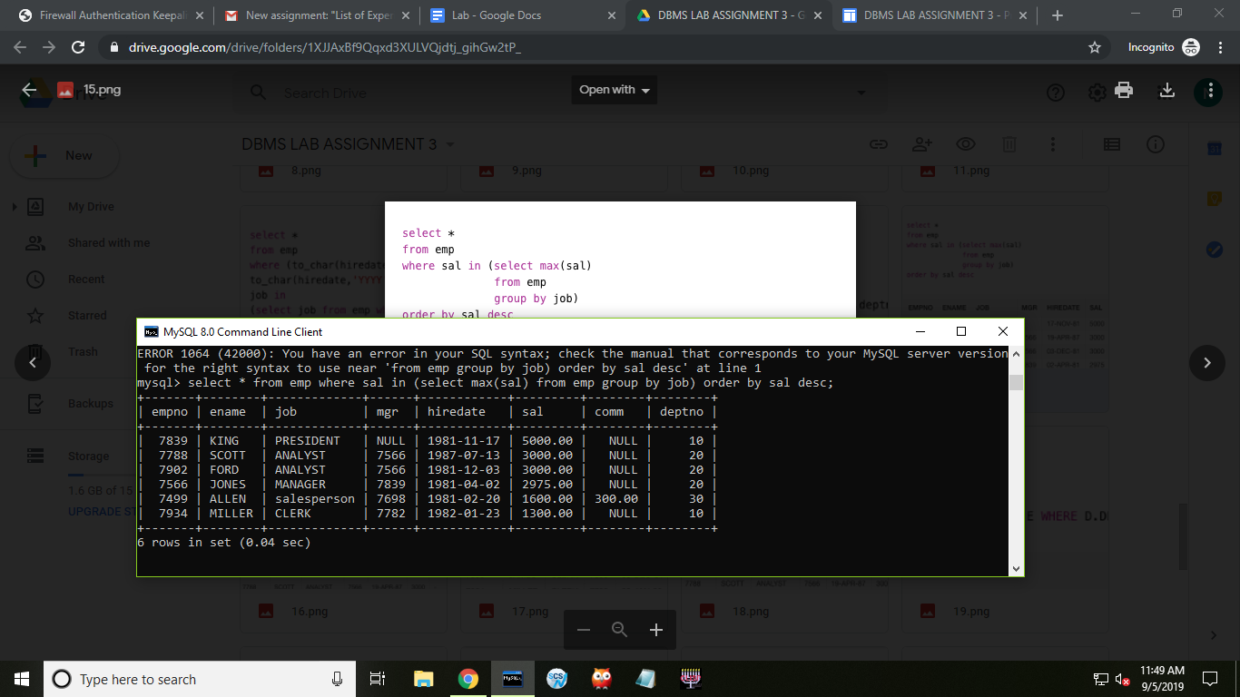

16. mysql> select * from emp where sal in(select min(sal) from emp group by job) order by sal asc;

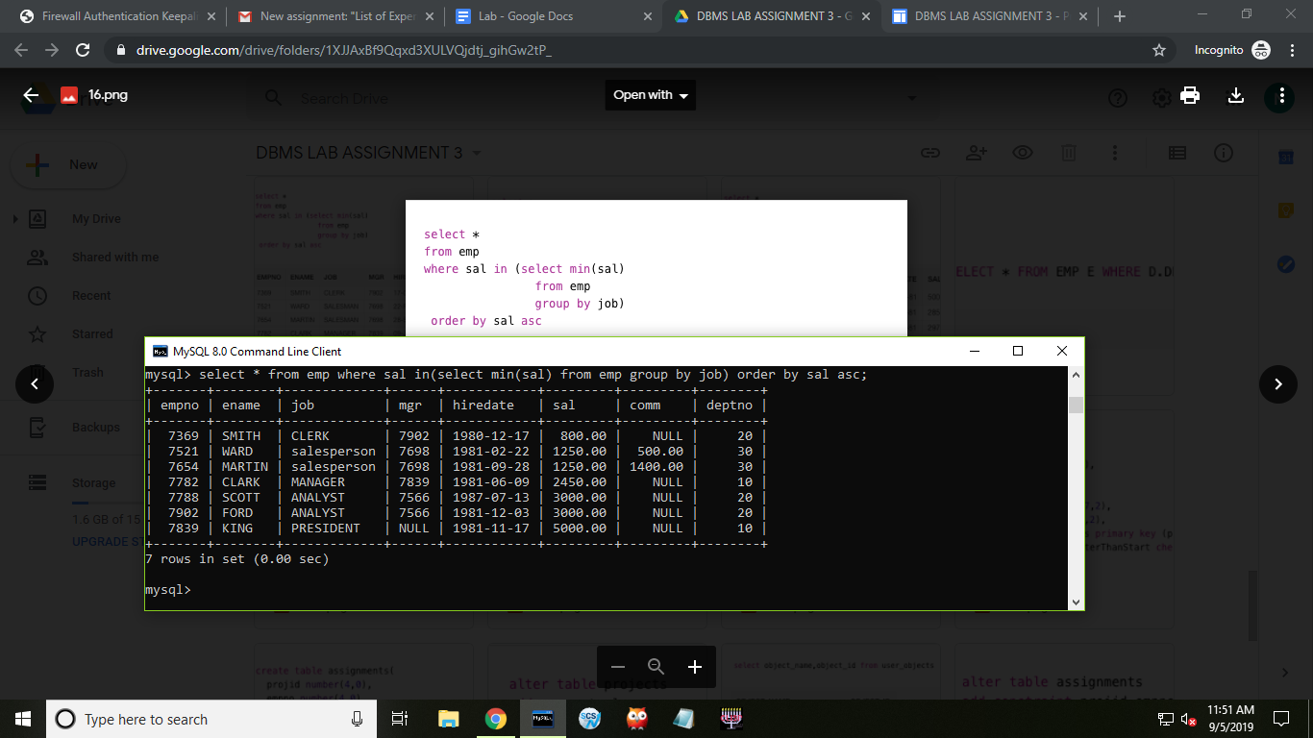

17. mysql> select * from emp e where hiredate in (select max(hiredate) from emp where e.deptno=deptno) order by hiredate;

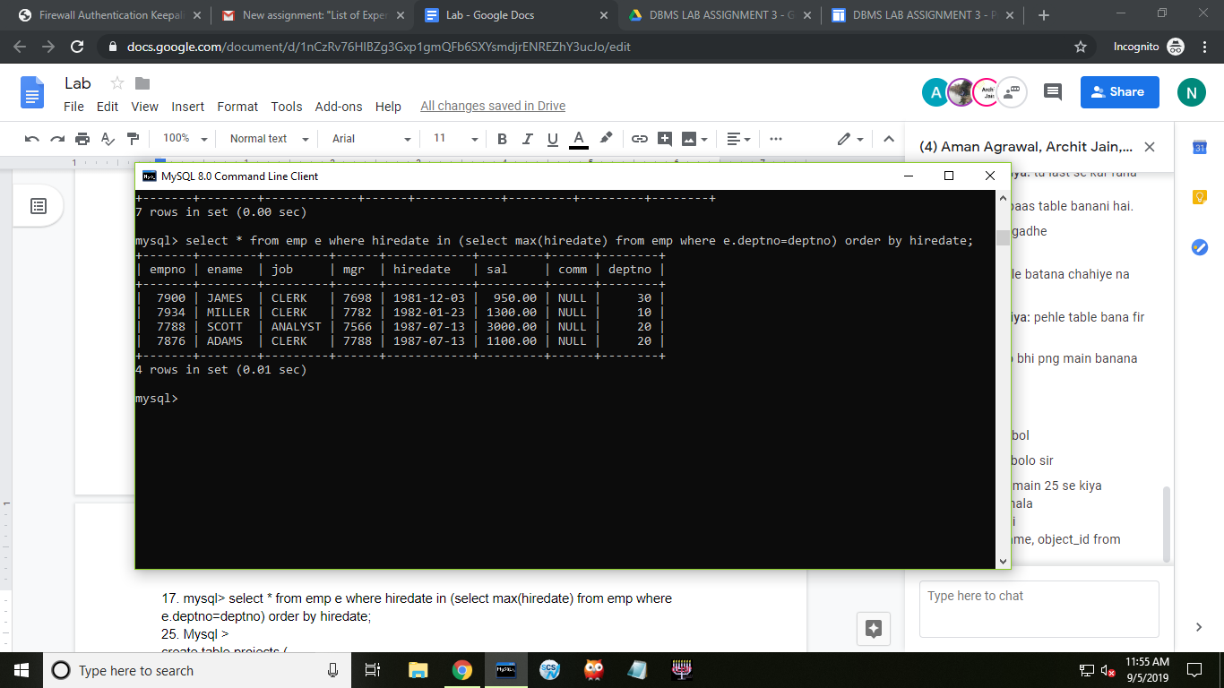

18. mysql> select * from emp e where sal>(select avg(sal) from emp where e.deptno=deptno);

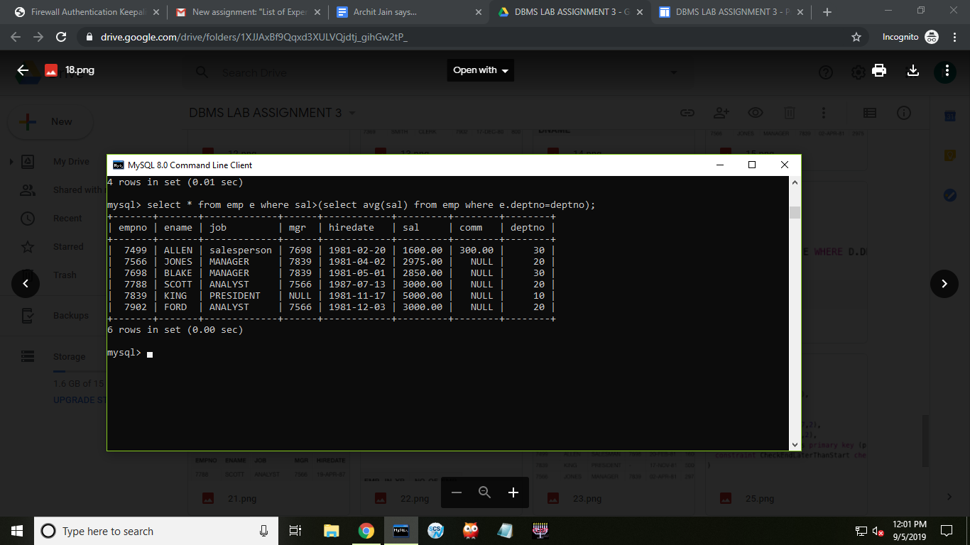

19. mysql> select d.dname from dept d where not exists (select * from emp e where d.deptno=e.deptno);

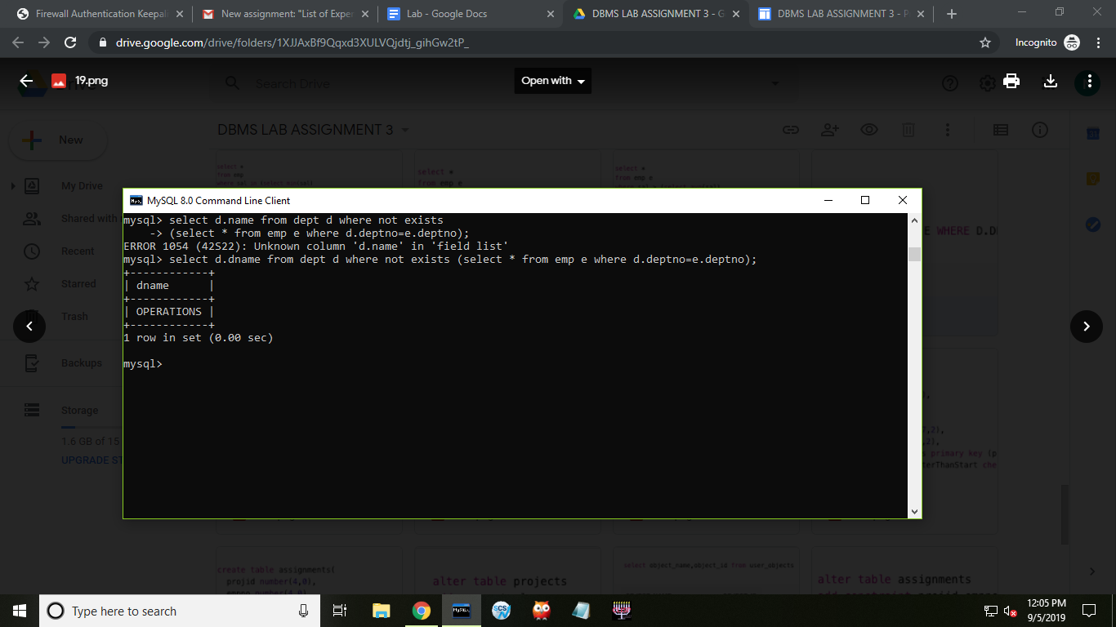

21.mysql> select ename,sal from emp order by sal desc limit 3;

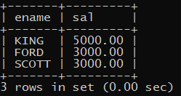

22.mysql> select year(hiredate),count(*) from emp group by year(hiredate) order by count(*) desc limit 1;

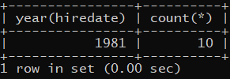

23. mysql> select * from emp e,(select deptno,avg(sal) avg_sal from emp group by deptno) e1 where e.deptno=e1.deptno and e.sal>e1.avg_sal;

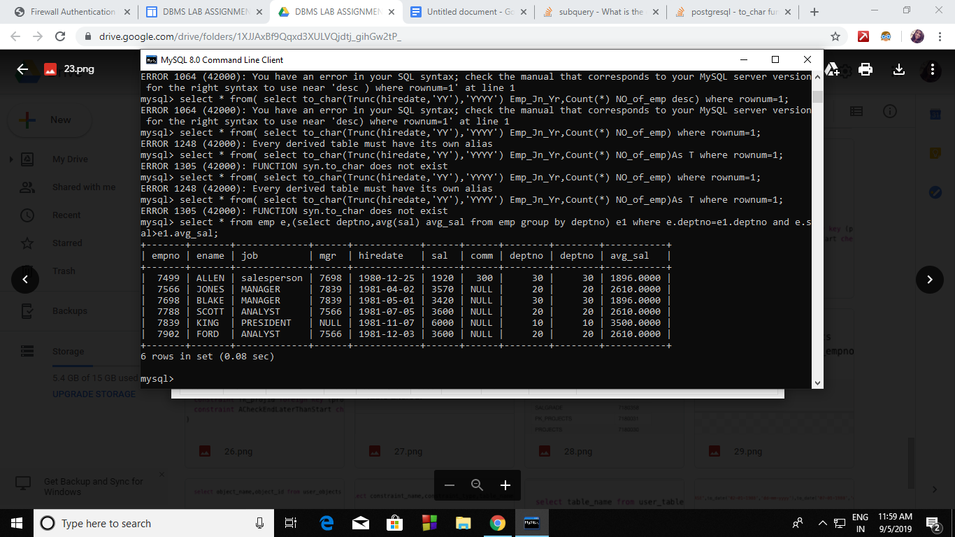

25. Mysql >

create table projects (

projid integer(4),

proj_desc varchar(10),

p_start_date date,

p_end_date date,

budget_amount float(7,2),

max_no_staff float(7,2),

constraint pk_projects primary key (projid),

constraint CheckEndLaterThanStart check (p_end_date >= p_start_date)

)

;

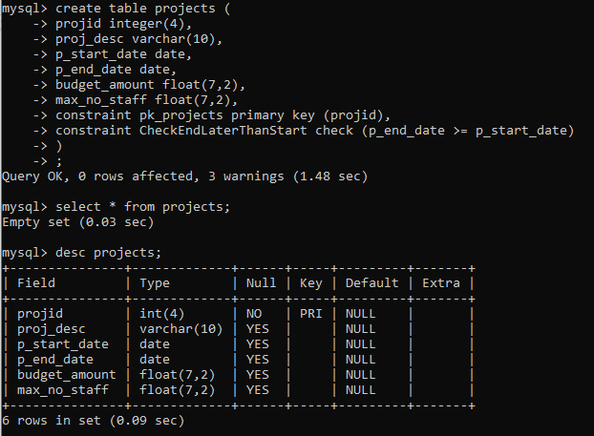

26. mysql >

create table assignments (

projid integer(4),

empno integer(4),

a_start_date date,

a_end_date date,

bill_rate integer(4),

assign_type integer(4),

constraint fk_projid foreign key(projid) references projects (projid),

constraint ACheckEndLaterThanStart check (a_end_date >= a_start_date)

);

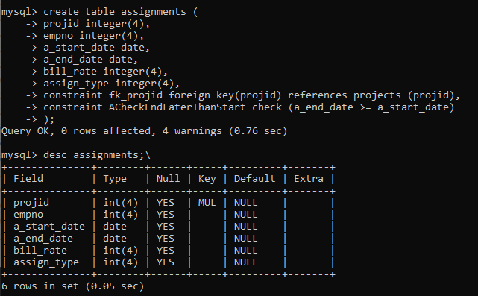

27. mysql>

alter table projects

add comments long;

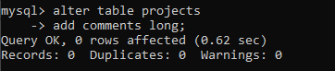

alter table assingments

add hours integer;

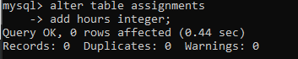

28. mysql>